Course: CS481- Big Data Analytics Instructor: Prof. Wadii Boulila

Lab 3: HBase Fundamentals: Table Design, CRUD, and Admin Basics

Objectives
In this lab, you will learn how to:
- Use HBase to create & describe tables, perform CRUD operations, apply schema changes, manage tables.

About HBase
HBase is a column-oriented database designed for Big Data solutions; which means it stores data tables by columns rather than rows. This makes data retrieval faster. Tables in it are however, sorted row wise and table schema is defined only through column families which are in other words the attributes. The column families work as key-value pairs.

Comparison between HDFS and HBase
Aspect | HDFS | HBase
Type | Distributed file system | Distributed NoSQL database
Built on | Runs on a cluster (NameNode + DataNodes) | Runs on top of HDFS (HMaster + RegionServers + ZooKeeper)
Best for | Storing big files; batch ETL/analytics | Fast random reads/writes at scale (online serving)
Data model | Files & folders (bytes) | Tables → row key → column families/columns (versioned cells)
Access pattern | Sequential/streaming, high throughput | Row/column get/put/scan, low latency
Querying | Use engines (MapReduce, Spark, Trino) | API or SQL via Apache Phoenix
Typical uses | Data lake, logs, Parquet/ORC, archives | Time-series/IoT, user profiles, counters, lookups

HBase Architecture
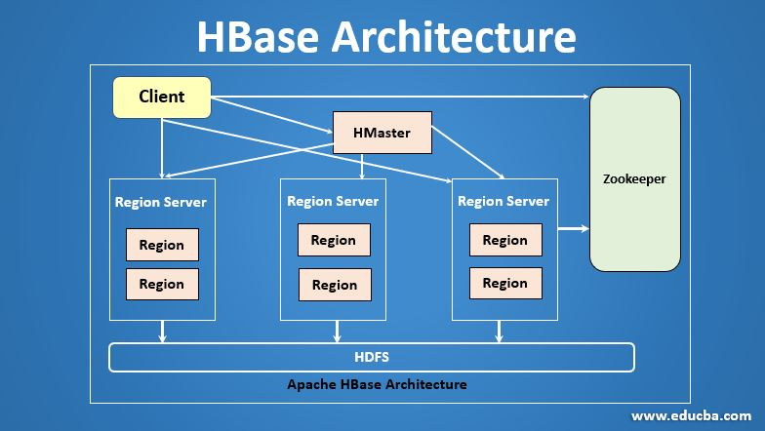
The HBase architecture is composed by:
- HDFS (bottom): durable storage for HBase files (HFiles, WAL) with replication.
- RegionServers: workers that host table Regions (shards). They serve all reads/writes.
- HMaster: coordinator—assigns/moves regions, handles splits/merges, schema changes, and load balancing. It’s not on the hot read/write path.
- ZooKeeper: keeps cluster state (who is alive, where meta/regions live). Clients query ZooKeeper to discover region locations.
- Client flow: client → ZooKeeper to find region → talks directly to the right RegionServer for low-latency access.

HBase Advantages
- Low-latency random I/O: Millisecond get/put/scan on huge tables (serving/OLTP-like access at scale).
- Horizontal scalability: Auto-sharded regions split/move across RegionServers; near-linear scale-out.
- Strong per-row consistency: Atomic updates within a row (across column families) + WAL for durability.
- Wide, sparse columns: Efficient for semi-structured data; store only populated cells.
- Multi-versioned cells: Keep time-stamped versions; easy history/temporal queries; per-family TTLs.
- Compression, Bloom filters, BlockCache: Smaller storage and faster reads on hot data.
- Bulk ingestion & Hadoop synergy: HFiles on HDFS; integrates with MapReduce/Spark for ETL; fast bulkload path.
- Server-side processing: Filters, coprocessors, counters/increments reduce data movement.
- Operational resilience: Region failover, replication, snapshots; Kerberos/ACLs for security.
- SQL option: Apache Phoenix adds SQL, secondary indexes, and JDBC access when needed.

General Commands
  - create - Creates a table.
  - list - Lists all the tables in HBase.
  - disable - Disables a table.
  - is_disabled - Verifies whether a table is disabled.
  - enable - Enables a table.
  - is_enabled - Verifies whether a table is enabled.
  - describe - Provides the description of a table.
  - alter - Alters a table.
  - exists - Verifies whether a table exists.
  - drop - Drops a table from HBase.
  - drop_all - Drops the tables matching the ‘regex’ given in the command
  - put - Puts a cell value at a specified column in a specified row in a particular table.
  - get - Fetches the contents of row or a cell.
  - delete - Deletes a cell value in a table.
  - deleteall - Deletes all the cells in a given row.
  - scan - Scans and returns the table data.
  - count - Counts and returns the number of rows in a table.
  - truncate - Disables, drops, and recreates a specified table.

Starting Hadoop services
Make sure the hadoop services are up:
startCDH.sh

Starting HBase Shell
Command: hbase shell

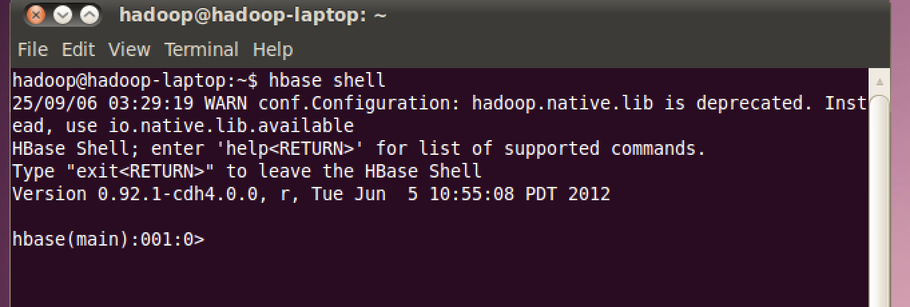

Exiting HBase Shell
Command: exit

View existing tables in HBase
Command: list

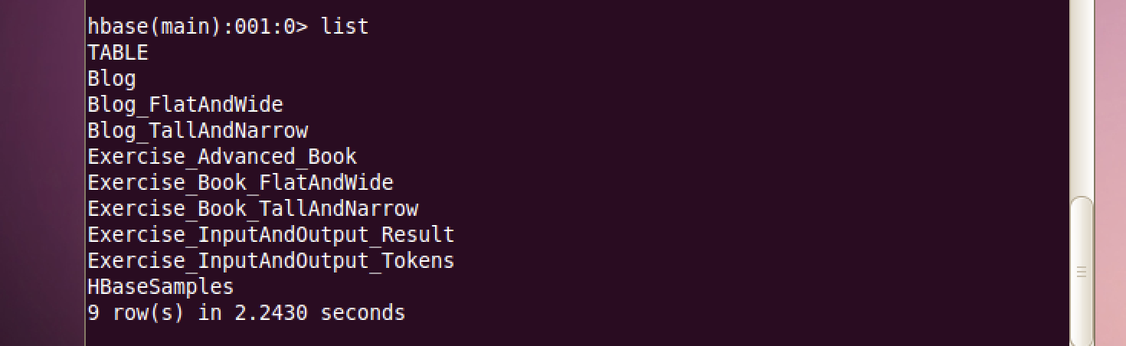

View existing servers in HBase
Command: status
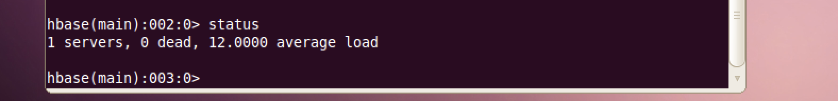

View version of HBase in use
Command: version

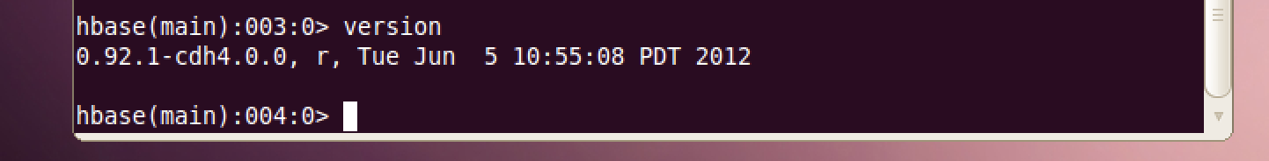

To open guide for used commands in HBase
Command: help
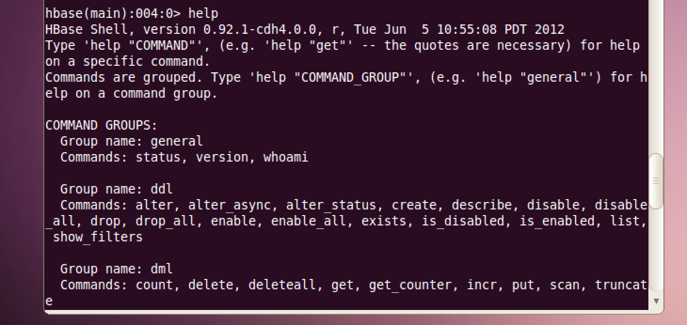

To open guide for tables manipulation in HBase
• Per-command help (tables):
help "list" ·help "describe" · help "exists" · help "create" · help "alter" · help "disable" · help "enable" · help "drop" · help "truncate"
• Data ops help:
help "put" · help "get" · help "scan" · help "count" · help "delete"
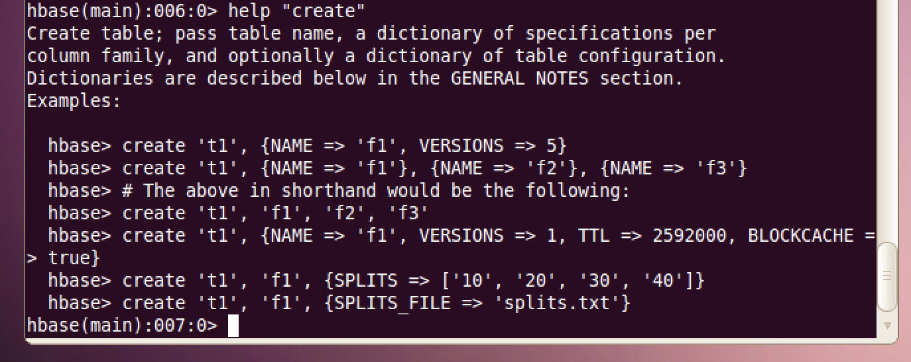

Create table in HBase
Command:
create 'ecommerce_transactions','amount','card_type', 'websitename', 'countryname', 'datetime', 'transactionID', 'cityname', 'productname'
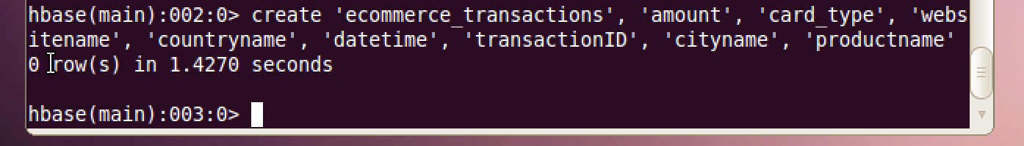

Insert rows for tables in HBase
Command:
put 'ecommerce_transactions', '2', 'card_type', 'MasterCard'
put 'ecommerce_transactions', '3', 'card_type', 'Visa'
put 'ecommerce_transactions', '4', 'card_type', 'MasterCard'
put 'ecommerce_transactions', '5', 'card_type', 'Maestro'
put 'ecommerce_transactions', '1', 'amount', '50.87'
put 'ecommerce_transactions', '2', 'amount', '1023.2'
put 'ecommerce_transactions', '3', 'amount', '3321.1'
put 'ecommerce_transactions', '4', 'amount', '234.11'
put 'ecommerce_transactions', '5', 'amount', '321.11'

Scan all rows in a table in HBase
Command: scan 'ecommerce_transactions'
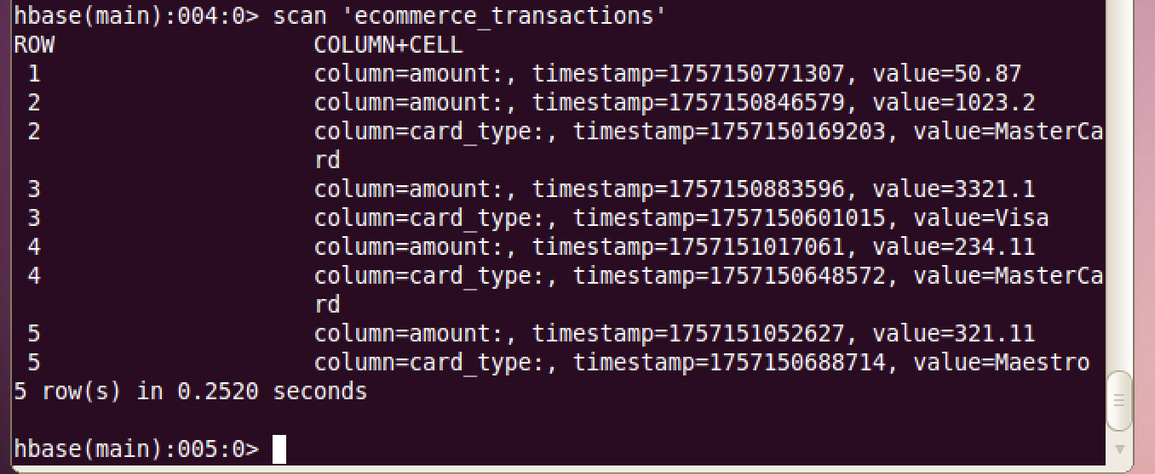

Get transactions for only row value 2 and 3 in HBase
Command:
get 'ecommerce_transactions', '2'
get 'ecommerce_transactions', '5'

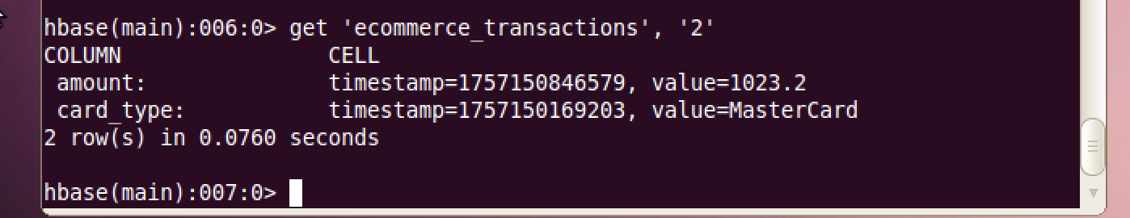

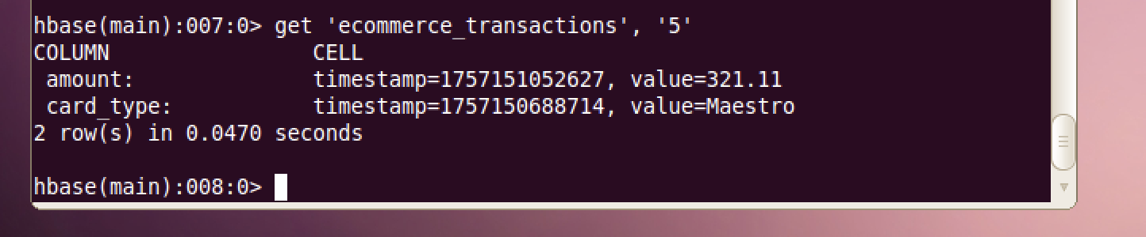

Get description of the table in HBase
Command:
describe 'ecommerce_transactions'

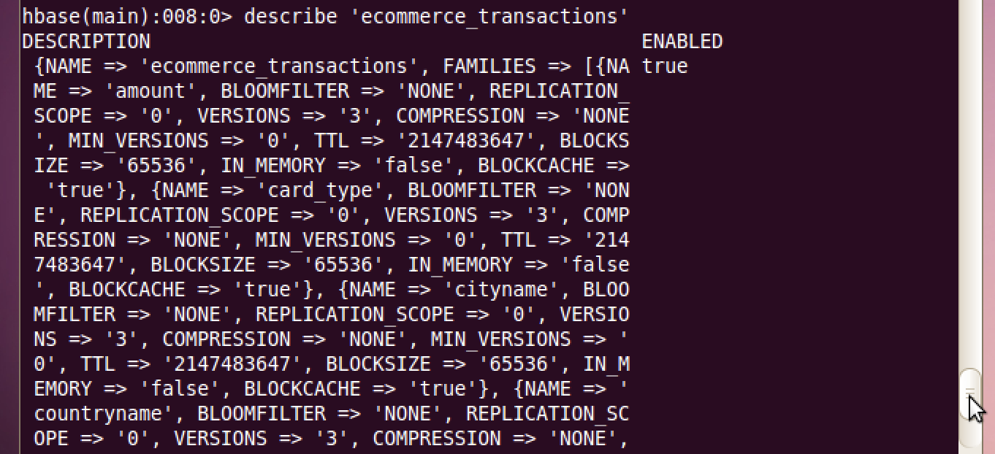

Alter is the command used to make changes to an existing table.
This command can help change the maximum number of cells of a column family, set and delete table scope operators, and delete a column family from a table.
Command:
alter 'ecommerce_transactions', NAME = > 'card_type', VERSIONS = > 5
- Table: Targets the ecommerce_transactions table.
- Action: Adds or modifies the column family card_type.
- VERSIONS => 5: Sets the maximum number of cell versions for the card_type column family to 5, allowing up to 5 historical versions of each cell to be stored (useful for tracking changes over time).
- Effect: Updates the table schema dynamically; if card_type already exists, it adjusts its version setting; if new, it creates the column family with this configuration.
In HBase 0.92 you must disable a table before changing its schema (e.g., altering a column family’s VERSIONS).
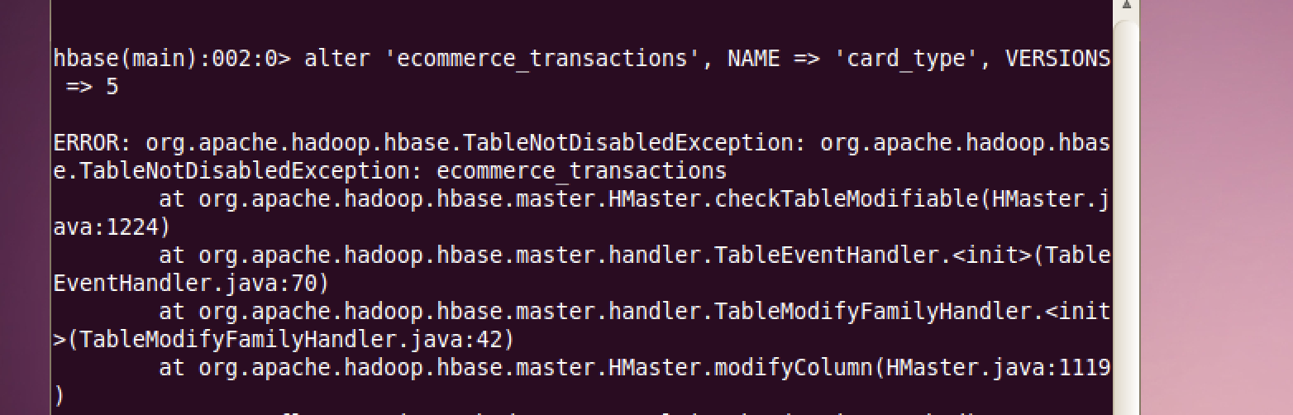

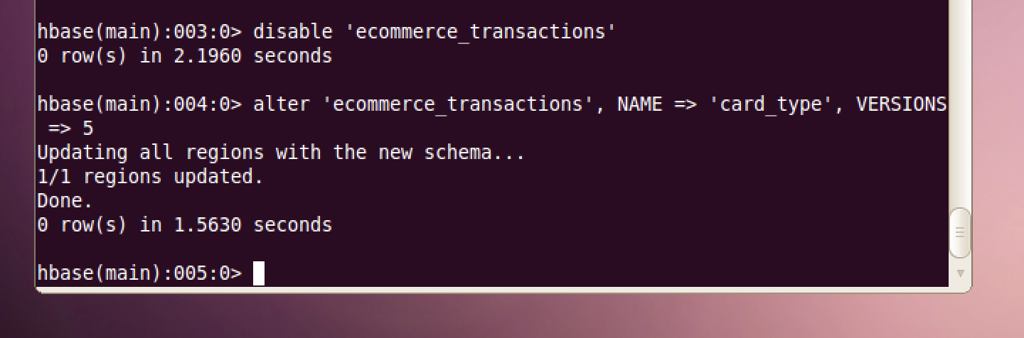

Deleting a cell in a table in HBase
Command:
delete 'ecommerce_transactions', '4', 'card_type'

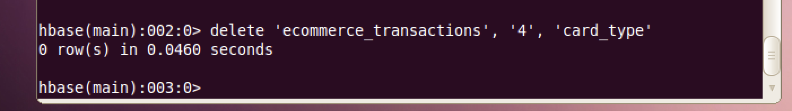

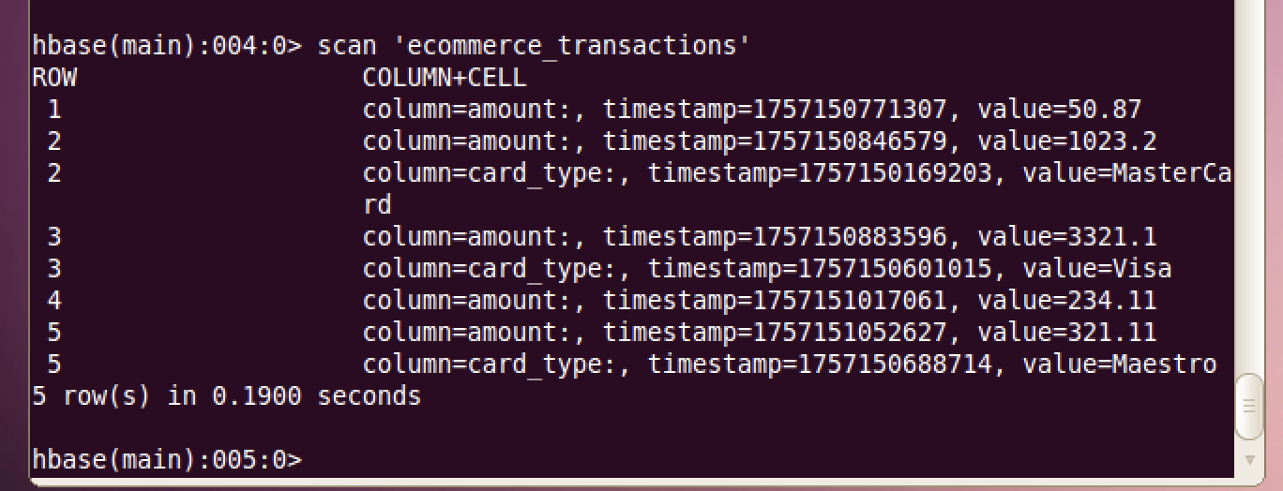

Deleting a row in a table in HBase
Command:
deleteall 'ecommerce_transactions’, '4'

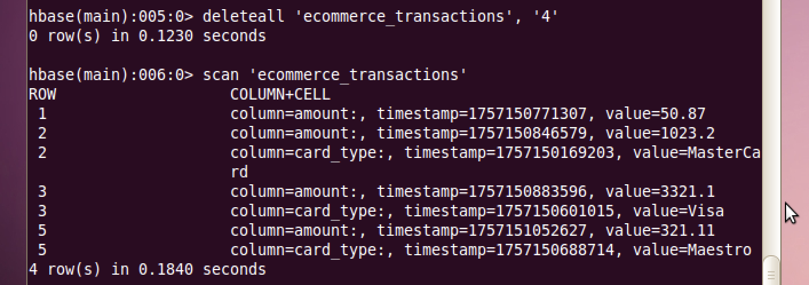
Count number of rows in a table in HBase
Command:
count 'ecommerce_transactions'

Disable, drop and recreate a table in HBase
Command:
truncate 'ecommerce_transactions'

Drop a table of HBase
Command:
drop 'ecommerce_transactions’
Note that drop won’t work till the table has been disabled.

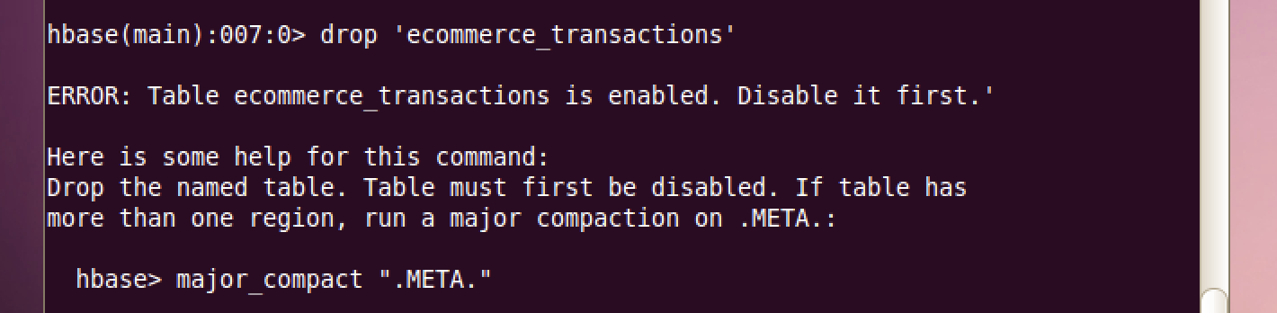

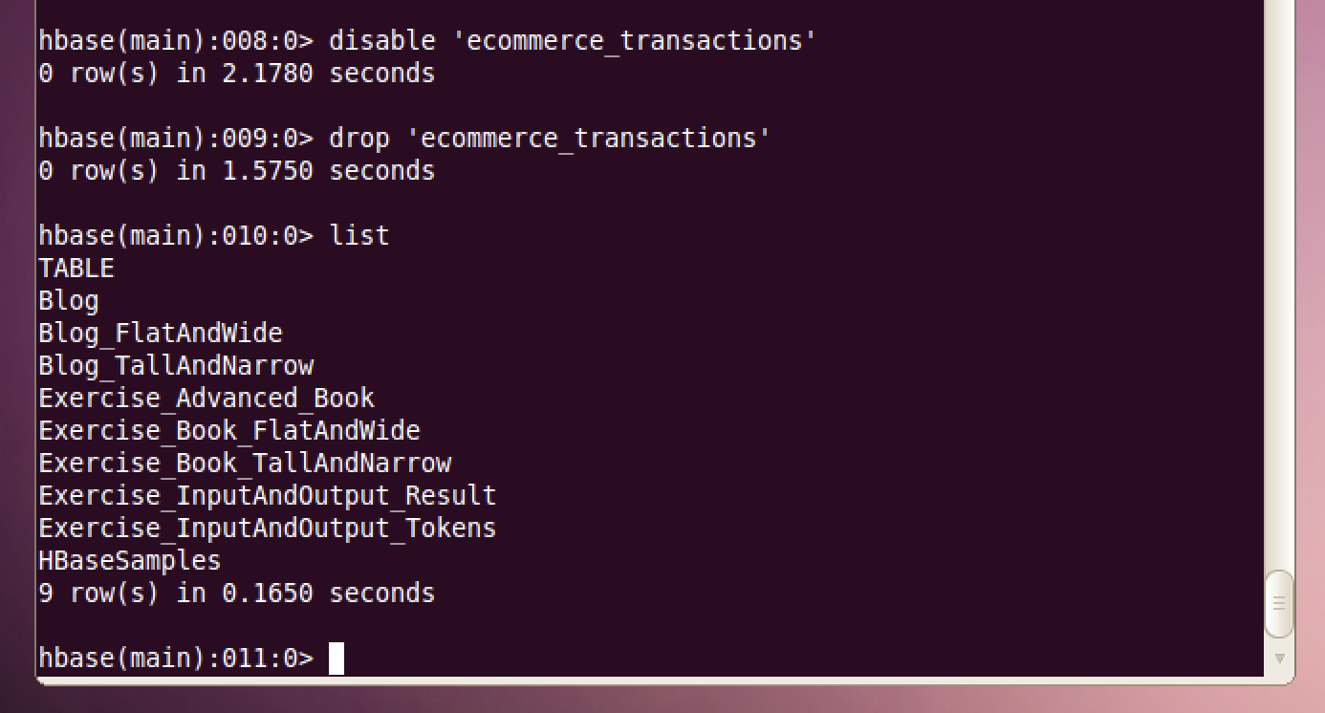

Check if a table is present in HBase:
Command:
exists 'ecommerce_transactions'

Hands-On Tasks
- Create a table named lab_orders with three column families: cust, order, pay.
- Insert at least 5 rows (e.g., keys o1–o5) with: customer name, order date, order status, and payment amount. Show a full table scan and retrieve one specific row by key. Report the total row count.
  - (If using older HBase, remember schema changes may require disabling/enabling the table.)
- Delete a single cell (e.g., the payment amount of one row) and verify the effect. Delete an entire row and verify the new row count and scan output.
- List existing tables; check existence and state (enabled/disabled) of lab_orders.
- Compare truncate vs drop on a small test table: describe the practical difference based on your observations.
Deliverables: screenshots or copied outputs for each step (schema description, scans/gets with versions, counts), plus 1–2 sentences interpreting each action’s effect.

